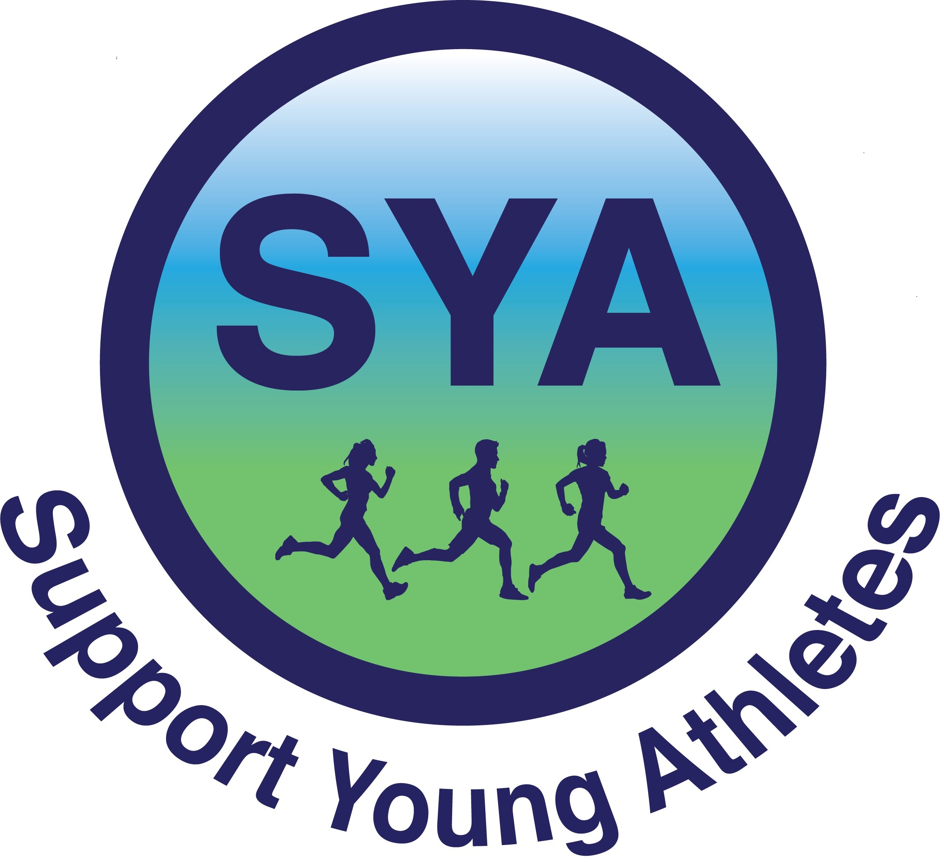

Publicity and Photo Release Form

I hereby grant to Support Young Athletes (SYA) the absolute and irrevocable right and unrestricted permission to use my name, story, likeness, image, voice,
and/or appearance as such may be embodied in any photos, video recordings, audiotapes, digital images, and the like, taken or made on behalf of SYA or its partners. I agree that SYA has complete ownership of such material and can use said material for any purpose consistent with SYA’s mission. These uses include, but are not limited to,
videos, publications, advertisements, news releases, Web sites, social media and any promotional or educational materials in any medium. I acknowledge that I will not receive any compensation for the use of such images, video, likeness, etc.
I hereby release and discharge SYA, and its agents, representatives and assignees
from any and all claims and demands arising out of or in connection with the use of my name, story, likeness, image, voice and/or appearance, including any and all claims for invasion of privacy, right of publicity, misappropriation or misuse of image, and/or defamation.

I represent that I am over the age of eighteen (18) years and that I have read the foregoing and fully understand its contents.* This release shall be binding upon me, my heirs, legal representatives, and assigns.
This agreement is being made and entered into under the laws of the State of California and shall be governed and interpreted in accordance with the laws of said state. This agreement embodies the entire agreement of the parties (subject and photographer). No modification of his agreement shall be of any effect unless it is made in writing and signed by all of the parties to the agreement.

Name (Printed): ______________________________________________________
Signature: ________________________________ Date: ___________________
* If the person signing is under the age of 18, consent from a parent or guardian is needed.
I hereby certify that I am the parent or legal guardian of
______________________________, named above, and do hereby give my consent
without reservation to the foregoing on behalf of this individual.
Parent/Guardian’s Name (Printed): _________________________________________
Parent/Guardian’s Signature: ________________________ Date:_________________

